Myles J Sartor
Matthew Griffin
STAT100-0121
October 3rd 2023
Problem Set 4
1a. Age group is the explanatory variable.
1b. Course credit hours are the response variable.
(Qual-Quant Case)
1c. 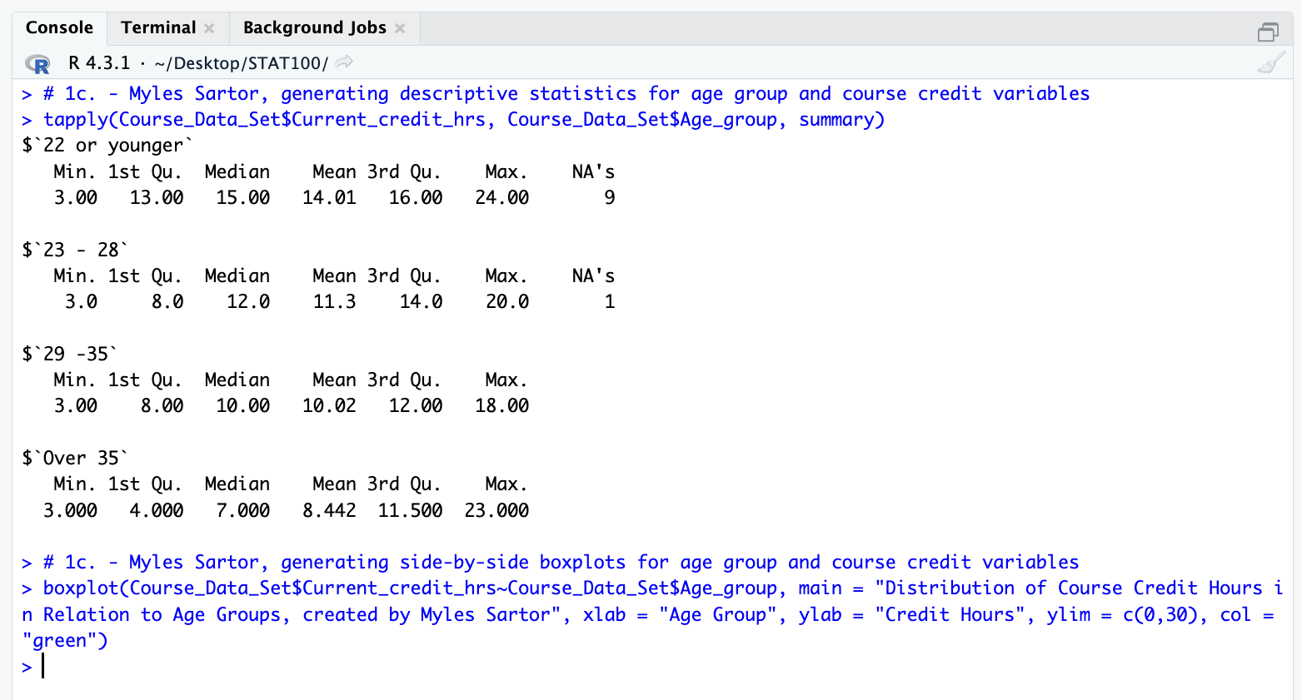
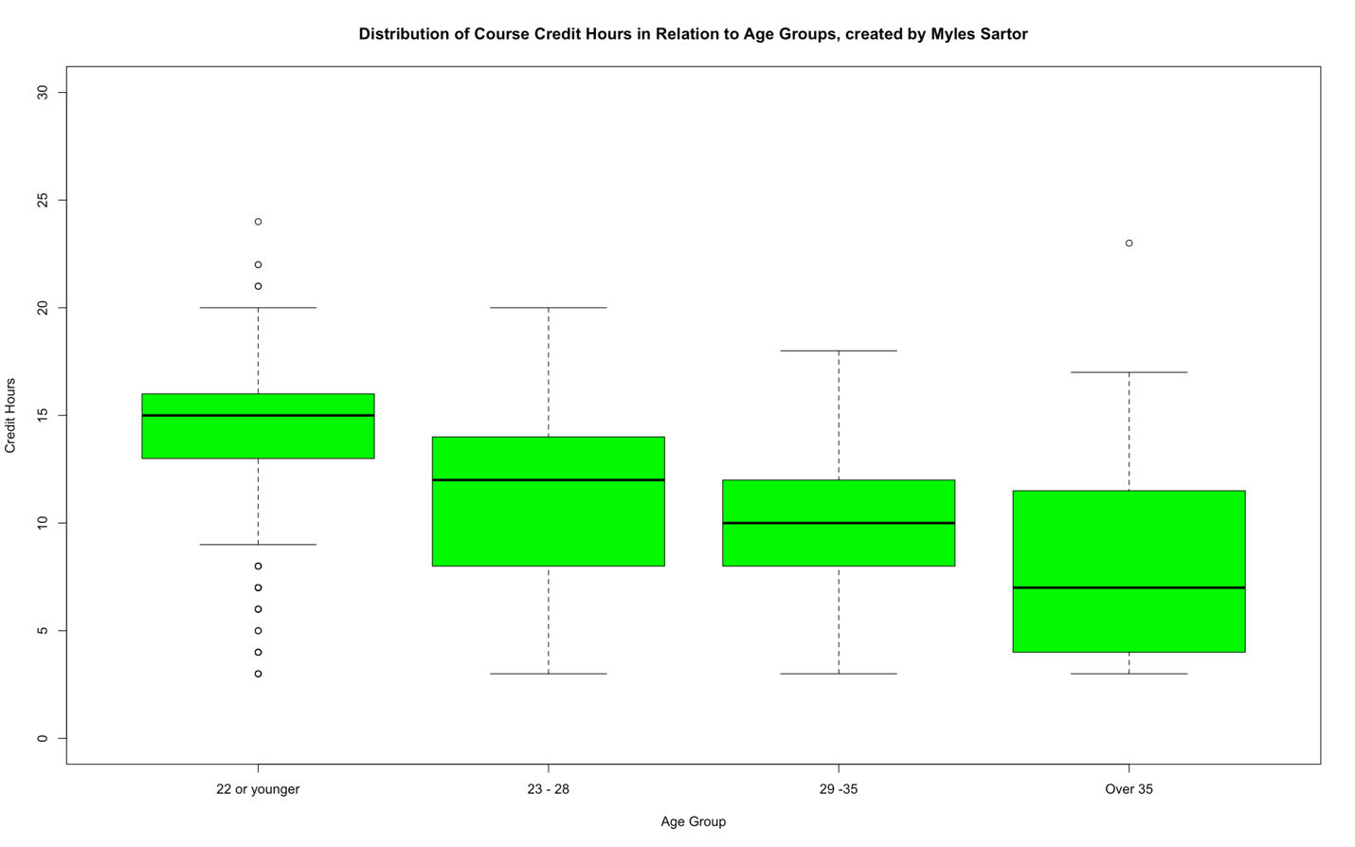
1d. The 22 or younger age group has the highest median number of enrolled credits in the data set at 15.00.
1e. The over-35 age group has the lowest median number of enrolled credits in the data set at 7.00.
1f. Yes, there is a clear relationship between a student’s age group and the number of enrolled credits for the student based on the generated descriptive statistics and side-by-side box plots. The younger the student is, the more credit hours they typically enroll in, whereas the older the student is, the fewer they enroll in. In other words, as one gets older, they enroll in fewer credit hours than they did when they were younger (Gradually decreases in each age group).
2a. Age group is the explanatory variable.
2b. Smartphone type is the response variable.
(Qual-Qual case)
2c. 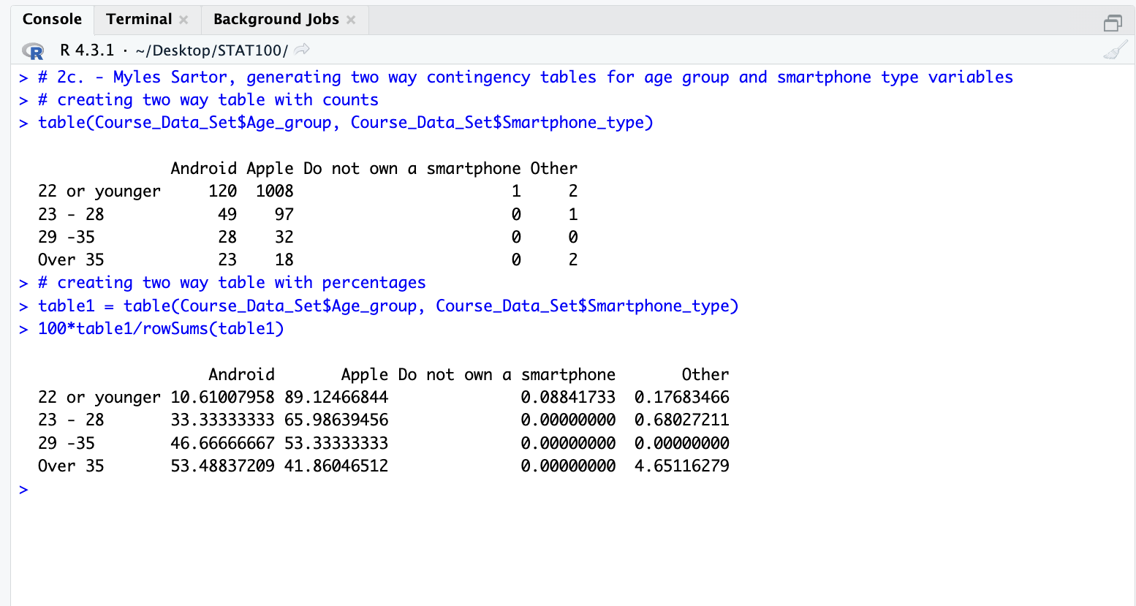
2d. Based on the information from the given data display, only 10.61 % of students in the 22 or younger group own an Android device.
2e. Based on the information from the given data display, 53.49 % of students in the over-35 age group have an Android device.
2f. Yes, there is a relationship between a student’s age group and the student’s smartphone type. The information in the table’s data display shows that younger students are more likely to choose an Apple device over an Android device, whereas older students start showing some increasing chances to choose an Android device instead of Apple. In other words, as the student gets older, the amount of them picking an Android device increases (The percentage gradually increases until it overtakes the number of students picking Apple devices once over the age of 35). Even though most students are picking Apple devices in the age groups (3 out of the 4), the Android device percentages are still increasing as the students get older (Every group after the first).
3a. The BMI is the explanatory variable.
3b. The body fat percentage is the response variable.
(Quant-Quant case)
3c. 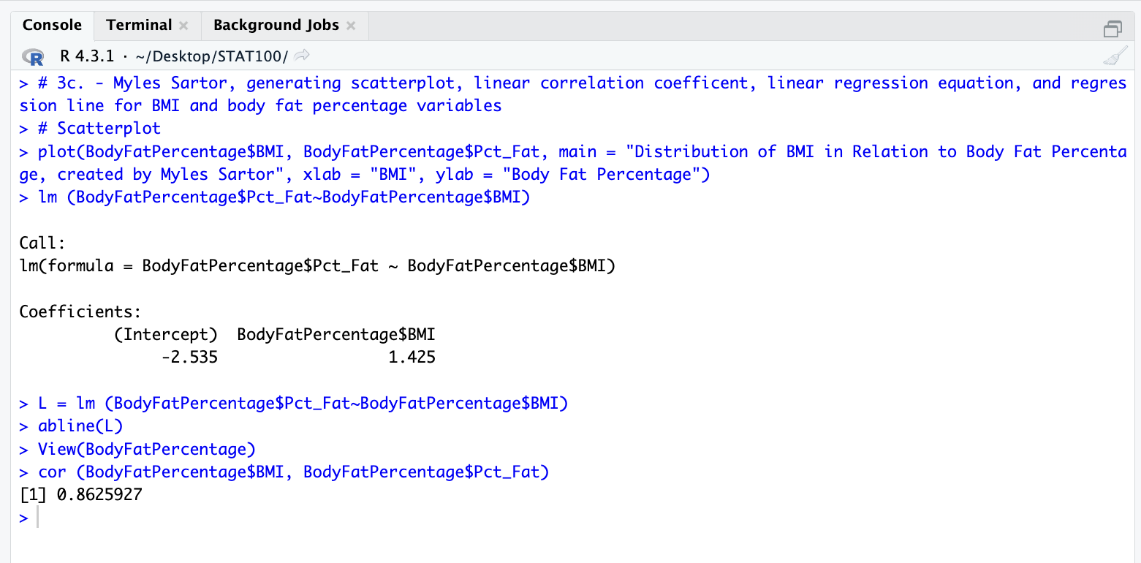
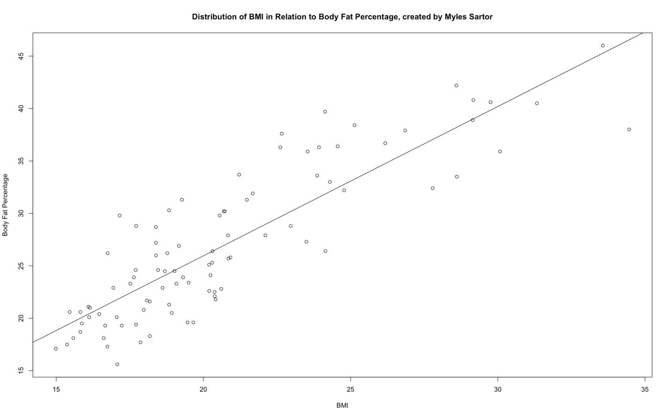
3d. The value of the correlation coefficient (r) generated by RStudio for this relationship is 0.8625927.
3e. This correlation coefficient tells us that the strength of the linear relationship for the given scatterplot of BMI and body fat percentage is a very strong positive one, since it is really close to positive 1. The general criteria for the correlation coefficient indicate that this is true, since values over 0.5 have good strength in the positive direction (Upward to the right).
3f. The least-squares linear regression equation for this relationship is:
y = 1.425(BMI) + (-2.535) (y = mx + b form). It can also be written in these ways:
y = -2.535 + 1.425(BMI) (y = b + mx, same form, terms swapped).
y = 1.425(BMI) – 2.535 (y = mx + b form, accounting for the negative being added).
The slope (m) is 1.425, and the y-intercept (b) is -2.535.
3g. Using the regression equation from the previous question, we can plug 23.75 in for the x-value (The BMI), and get 31.31 % for the body fat percentage (y-value). By writing out into the equation, we can show it like this:
y = 1.425(23.75) – 2.535, and the resulting y ends up being 31.31 %.
3h. Based on the given information from the scatterplot data display and line, it appears as though there is a relationship between a girl’s BMI and body fat percentage. Since the linear relationship is a very strong positive one, we can confidently say that as the girl’s BMI increases, the girl’s body fat percentage is also increasing. The strong positive line means that it is only physically possible for the y-value (body fat percentage) to increase if the x-value (BMI) increases to begin with. Obviously, there are going to be some outliers along the scatterplot (like with every data set), but this rule will remain true for most of the data set since the correlation coefficient is so strong (0.86).

